Weekly Construction Progress Report – Week 39
Harrow Bay Offshore Wind · 21 Sep – 27 Sep 2026
Elena Márquez · 28 September 2026 · HB-PM-RPT-2026-W39

1. Summary
No monopile was installed this week; the total remains 13 of 40. The foundation campaign is 3 piles behind the Rev 2 baseline (16 planned). Waiting on weather amounted to 64 hours – well above the planning allowance of 25 hours per week.
Area | Status | Comment
Overall schedule | Red | 13/40 monopiles vs. 16 planned
Foundations | Red | TPs installed: 13
Offshore substation | Green | Topside installed 19 Aug
Cables | Red | Export cable 2 delay – HB-RISK-017
HSE | Green | No incidents

2. Progress
Metric | This week | Cumulative | Plan (cum.) | Variance
Monopiles installed | 0 | 13 | 16 | -3
Transition pieces installed | 0 | 13 | – | –
Waiting on weather (h) | 64 | 558 | – | –
Persons on board (avg.) | 93 | – | – | –
Man-hours MV Sea Atlas | 7,521 | 203,231 | – | –
Lost time injuries | 0 | 0 | 0 | 0
Recordable injuries | 0 | 1 | – | –
Near misses reported | 0 | 5 | – | –
HSE observation cards | 25 | – | – | –

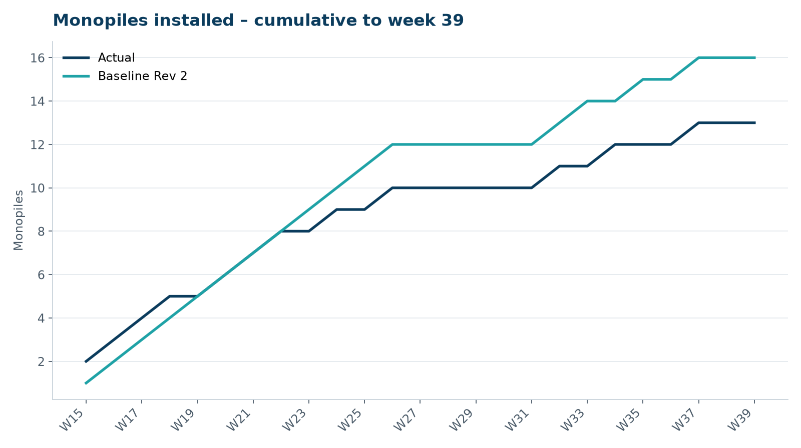
Figure 1 – Monopile installation progress, W15 to W39

3. Key activities this week
- 64 hours waiting on weather; HB-A14 pile pitched on 26 September, driving postponed after the wave forecast deteriorated.
- Steering Committee on 23 September approved the monopile recovery plan: exercise charter option 2 under WE-CON-2025-040 and move to 24/7 piling where the consent allows.
- Elena Márquez presented the project at the North Sea Energy Summit in Hamburg (22–24 September).

4. Health and safety
No lost time injuries. 25 observation cards submitted; top theme: access to the TP platform.

5. Environment
- No piling this week; passive acoustic monitoring stations HB-PAM-01 to -04 operational.

6. Issues and risks
- HB-RISK-017 export cable 2 delay – recovery programme received; resequencing of cable lay campaign in progress.
- HB-RISK-001 weather: 64 h downtime this week.
- HB-RISK-029 monopile campaign into winter – recovery plan approved by SteerCo.

7. Look-ahead next week
Complete HB-A14; install HB-B01 and HB-B02; start 24/7 piling once the fatigue management plan is approved.
Prepared by Project Controls (Gareth Lewis); approved by Elena Márquez. Distribution: project team, Steering Committee, Halden Turbine Systems, Lenders' Technical Adviser.

